|  |
| --- |
|  |
| 2D Platformer Game |
| **Assignment#2** |
| Version #1.0  All work Copyright © 2016 by GS Games.  All rights reserved. |
| **Guashti Singh** |
|  |

|  |
| --- |
| February 26, 2016 |

**Table of Contents**

Version History 3

I. Game Overview 4

II. Camera 4

III. Controls 4

IV. Menu and Screen Descriptions 4

V. Characters 5

VI. Enemies 6

VII. Items 6

VIII. Scoring 6

IX. Sound Index 6

X. Art / Multimedia Index 6

## Version History

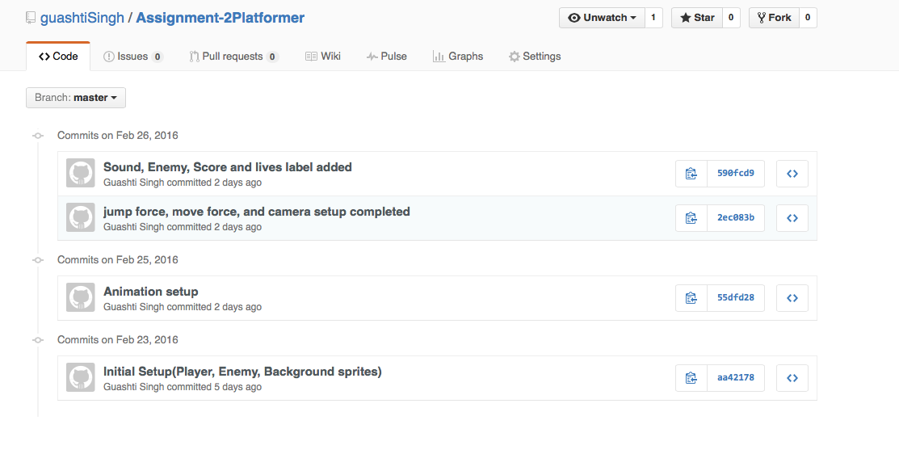

Github link: <https://github.com/guashtiSingh/Assignment-2Platformer>

## Game Overview

*The goal of the game is to use the keyboard to guide Princess Leya to the winning flagpole and help her to collect treasure (coins) without getting eaten by the piranha flower plant. For every piece of treasure that she obtains, Princess Leya earns 10 points. Piranha plant is trying to stop her from collecting treasure and winning the game. Every time the enemy (piranha plant) catches her, she loses a like. Princess Leya has a total of 5 lives, when all of her lives are lost the game over screen appears. If Princess Leya collects the treasure and reaches the flagpole the player wins the game.*

## Camera

*The camera’s point of view in the 2D game is an orthographic view and a script is written so that the camera follows the player*

## Controls

*The up arrow on the keyboard is used for jumping. The side arrows are used to move the player across the screen.*

## Menu and Screen Descriptions

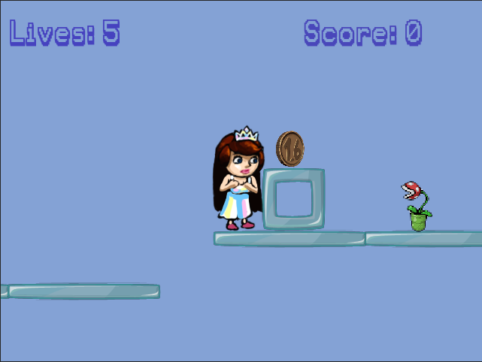



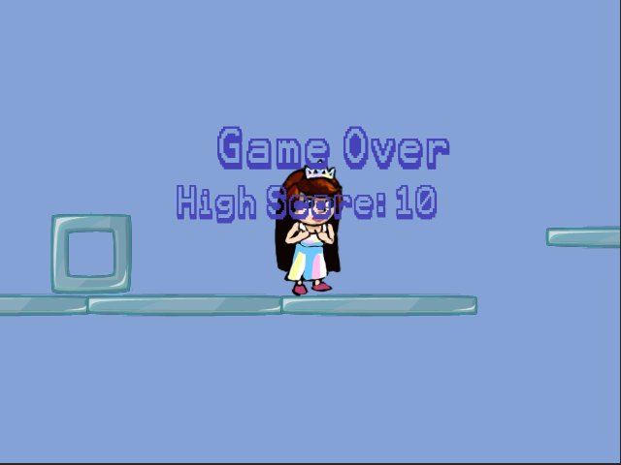

## Characters

*Princess Leya – main character, her aim is to collect treasure and get to the flagpole in order to win the game*

*Piranha Plant –his aim in the game is to capture/block Princess Leya from winning and finding treasure, forcing her to lose lives*

## Enemies

*Piranha Flower Plant is the enemy. He is placed several times in the game. He wants Princess Leya to lose lives and he tries to make her collect the least amount of treasure.*

## Items

*The coin item placed in the game screen to help Princess Leya score points in the game.*

## Scoring

*Every time Princess Leya collects coins she gains 10 points.*

## Sound Index

*Hit_Hurt2.wav – is played when Princess Leya dies or collides with the enemy*

*Jump.wav – is the sound that Princess Leya makes when she jumps*

*Pickup_Coin.wav – is the sound that is made when she collects treasure (coins)*

## Art / Multimedia Index

|  |  |
| --- | --- |
|  | *Jump sprite (PrincessJump.png)* |
| *Macintosh HD:Users:ashtisingh:Desktop:Assignment#2Platformer:Assets:Sprites:PrincessIdle.png* | *Idle Sprite (PrincessIdle.png)* |
| *Macintosh HD:Users:ashtisingh:Desktop:Assignment#2Platformer:Assets:Sprites:PrincessRun.png* | *PrincessRun.png* |
| *Macintosh HD:Users:ashtisingh:Desktop:Assignment#2Platformer:Assets:Sprites:block.png* | *block.png* |
| *Macintosh HD:Users:ashtisingh:Desktop:Assignment#2Platformer:Assets:Sprites:PiranhaPlantSprite.png* | *PrinhaPantSprite.png* |
| *Macintosh HD:Users:ashtisingh:Desktop:Assignment#2Platformer:Assets:Sprites:Sprite Sheet 03.png* | *Sprite_Sheet_03.png (obtained from the asset store)* |
| *Macintosh HD:Users:ashtisingh:Desktop:Assignment#2Platformer:Assets:Sprites:goal.png* | *goal.png* |
| *Computer Font Pack 1.0*  *Font name used from the pkg.: paraaminobenzoic* | *Downloaded Ray Larabie font package from the asset store* |